April 1st to 30th 2026 Hutton Neighbourhood Report
Calls Received 25
Domestic:3 Missing person:2 Road related:2 Harassment:1 Other:3 Theft:3
Sexual offence:2 Abandoned 999:2 Public order:2 Concern for safety:1
Suspicious:1 Criminal damage:1 Threats :2

Please feel free to contact me with concerns by email or call 101/999

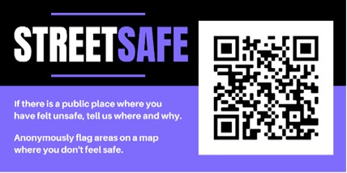

Please feel free to contact me with any ideas or thoughts regarding your area Please also see attached link for our street safe website Report feeling unsafe in public spaces (StreetSafe) | Avon and Somerset Police. This is a great way to report areas you feel unsafe, this maybe inadequate lighting problems with any other issues , this is not a way of reporting please still use 101/999 or online

